December
2017
We Are Called to Love and Be Loved
St. Michael Catholic School | 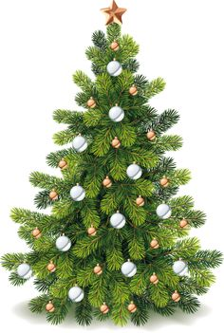
Sunday | Monday | Tuesday | Wednesday | Thursday | Friday | Saturday
 |  |  |  |  | 1 | 2
 |  |  |  |  | Christmas Raffle Draw #1!!
3 | 4 | 5 | 6 | 7 | 8 | 9
 | Tree/Wreath Delivery  4:00-6:00  Advent Liturgy @ 8:30 |  | Cinderella Production – 8:45  NCC “Integration Day” (Grade 8) | CSCA Meeting  6:30-8:00
10 | 11 | 12 | 13 | 14 | 15 | 16
 | Advent Litrugy @ 8:30 |  |  |  | Primary Mass (8:30-9:30)  Jr/Int Mass (9:45-10:45)
17 | 18 | 19 | 20 | 21 | 22 | 23
 | Advent Liturgy @ 8:30 |  | Christmas Sing-a-Long @ NCC  5:45 | Christmas Sing-a-Long @ NCC  5:45 | Last Day Before Christmas Holidays!
24 | 25 | 26 | 27 | 28 | 29 | 30
 | Merry Christmas!
31
PLEASE CHECK OUR NEWSLETTER AND WEBSITE REGULARLY FOR SCHOOL NEWS!

